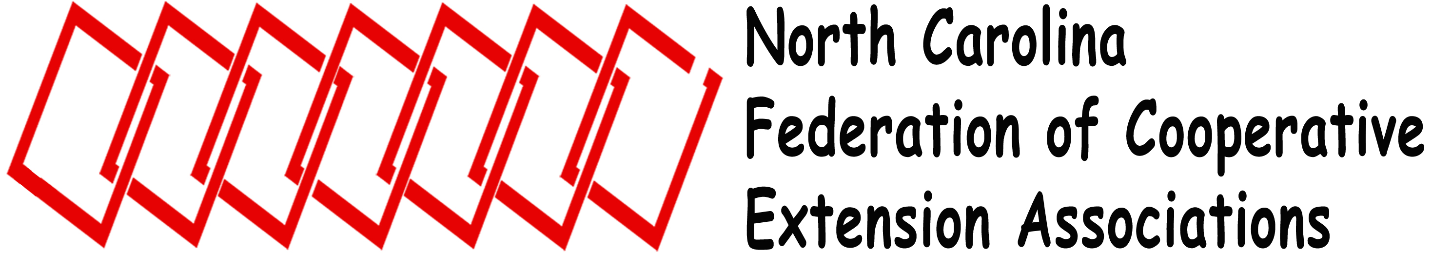
2013 Federation Board of Directors Meeting
Blackboard / Collaborate
Tuesday, May 28, 2013
1:00 pm – 3:00 pm

Call to Order / Determine Quorum Mitzi Downing, President
Approval of Agenda

Administrative Update Dr. Joe Zublena, Dean and Director Extension Administration

Minutes of 2012 Forum Meg Wyatt, Secretary

Treasurer’s Report Mary Hollingsworth, Treasurer
2013 Proposed Budget

Association Reports (4 minutes each, copy to Secretary)

NCCEAPA Tracy Brown NCAEPAAT Stephanie Minton ESP Crystal Smith
NCEAFCS Christine Smith NCACES Mitzi Downing NCAE4-HA April Bowman
NCACAA Cyndi Lauderdale

Unfinished Business
Review of Board Duties Mitzi Downing

New Business
2013 Annual Federation Forum Mitzi Downing & Cheryl Mitchell, President Elect

Fall 2013 Meeting Board Date

Adjourn

Officers / Board of Directors

Mission

The North Carolina Federation of Cooperative Extension Associations unifies North Carolina Cooperative Extension and promotes professional development and communicates concerns and needs of its members.
President Mitzi Downing NCACES
President-Elect Cheryl Mitchell NCCEAPA
Secretary Meg Wyatt NCAE4-HA
Treasurer Mary Hollingsworth NCACAA
Parliamentarian Debbie Stroud ESP
Webmaster Teresa Byrd NCAEPAAT
Past President Eleanor Summers NCEAFCS
NCCESA Jane McDaniels -– Tracy Brown
NCEAFCS Christine Smith – Molliy Alexi
NCAE4-HA April Bowman – Erin Morgan
NCAEPAAT Stephanie Minton – Hazel McPhatter
NCACES Mitzi Downing – Carolyn Bird
NCACAA Cyndi Lauderdale – Tyrone Fisher
ESP Crystal Smith – Mark Blevins

