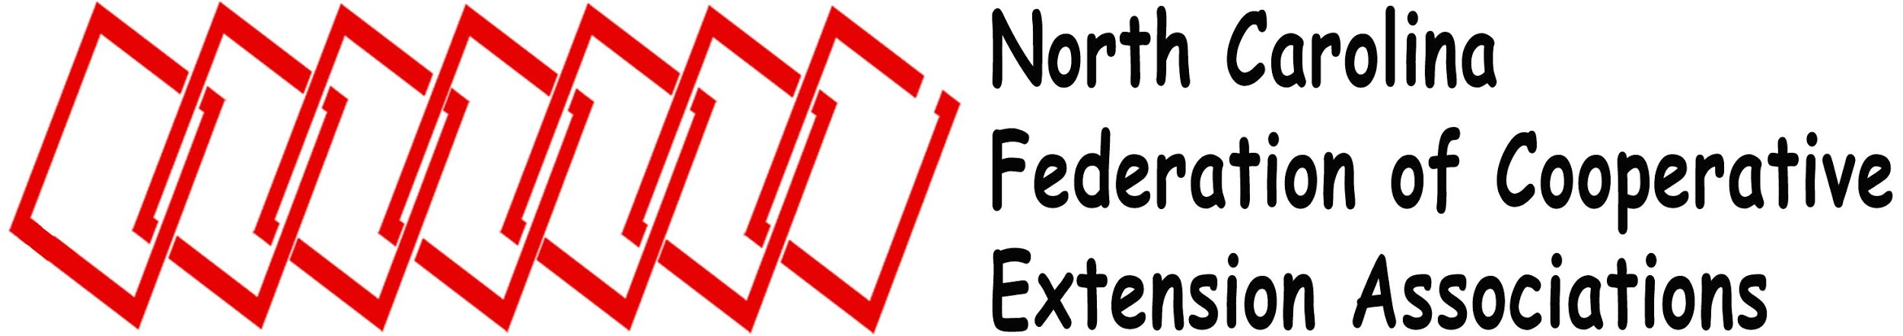
e

2018 Federation Forum
Stanly County Extension Center
26032-E Newt Rd, Albemarle, NC 28001
(704)983-3987
Friday, December 7, 2018
9:30 am – 2:00 pm

Refreshments / 9:30 am – 10:00 am

Welcome / 10:00 am Cameron Lowe, President

Association Roll Call Carinthia Cherry, Secretary

Introduction of Guests Toi Degree, President-Elect

------------------ Administrative Update & Discussion 10:15am -----------------

Moderation of Forum

----------------Luncheon / 12:00pm---------------
Moment of Thanks

Business Meeting / 12:30pm

Call to Order Cameron Lowe, President

Determine Quorum
Parliamentarian
Approval of Agenda

Minutes of 2017 Forum Carinthia Cherry, Secretary

Treasurer’s Report Sherry Lynn, Treasurer
2019 Proposed Budget

Association Reports (3 minutes each, copy to Secretary)

NCCEAPA Latoya Lucy NCAEPAAT Catherine Daniels ESP Tammy Kelly
NCEAFCS Hayley Cowell NCACES Sarah Blacklin NCAE4-HA Jackie Helton
NCACAA Travis Birdsell

Old Business

New Business

Proposed Constitutional Amendment and Name Change Cameron Lowe, President

Mission

The North Carolina Federation of Cooperative Extension Associations unifies North Carolina Cooperative Extension and promotes professional development and communicates concerns and needs of its members.
Recognition of 2018 Officers and Association Representatives
President Cameron Lowe ESP
President-Elect Toi Degree NCEAFCS
Secretary Carinthia Cherry NCACES
Treasurer Sherry Lynn NCCEAPA
Parliamentarian NCACAA
Webmaster Ashley Brooks NCAE4-HA
Past President Charissa Puryear NCAEPAAT
NCCEAPA Latoya Lucy
NCEAFCS Hayley Cowell
NCAE4-HA Jackie Helton
NCAEPAAT Sheila Gregory
NCACES Sarah Blacklin
NCACAA Travis Birdsell
ESP Tammy Kelly

Election and Installation of 2019 Federation Officers Charissa Puryear, Past President

President Jayne McBurney NCAEFCS
President Elect NCACES
Secretary NCCEAPA
Treasurer NCAE4-HA
Webmaster NCACAA
Parliamentarian Elizabeth Merrill NCAEPAAT
Past President Cameron Lowe ESP

2018 Federation Leadership & Service Recognition Award Cameron Lowe, President

Review/Announcement/Adjourn Cameron Lowe, President

We would like to thank our sponsor, the NC Soybean Producers Association, for their continued support of the Federation Forum.
The North Carolina Soybean Producers Association was the first state soybean board in the nation to combine the functions of checkoff-funded research and promotion activities and non-checkoff funded grassroots policy advocacy. The association strives to protect and support the legitimate interests of North Carolina’s soybean producers through the influence of government policies at local, state and national levels.
In addition, the association is the state affiliate of the American Soybean Association (ASA) in North Carolina. Delegates from the association participate in national policy development through the ASA resolutions process.
New in 2016, the NC Soy Alliance is a voluntary, dues-paying annual membership alternative for growers committed to advocacy and farm-friendly governmental policy. Through this program of the soybean association, growers receive their complementary membership to ASA. The motto of the NC Soy Alliance is “alliance is the core of advocacy.”
For more information please visit their website at: www.ncsoy.org

